# DATABASE SYSTEM PRACTICUM REPORT

# MODULE 9

**DCL**



**CREATED BY :**

**KURNIAWAN BAGASKARA**

**L200214253**

# INFORMATICS STUDY

# PROGRAM

**FACULTY OF COMMUNICATION AND INFORMATION SCIENCE MUHAMMADIYAH SURAKARTA UNIVERSITY**

PRACTICE

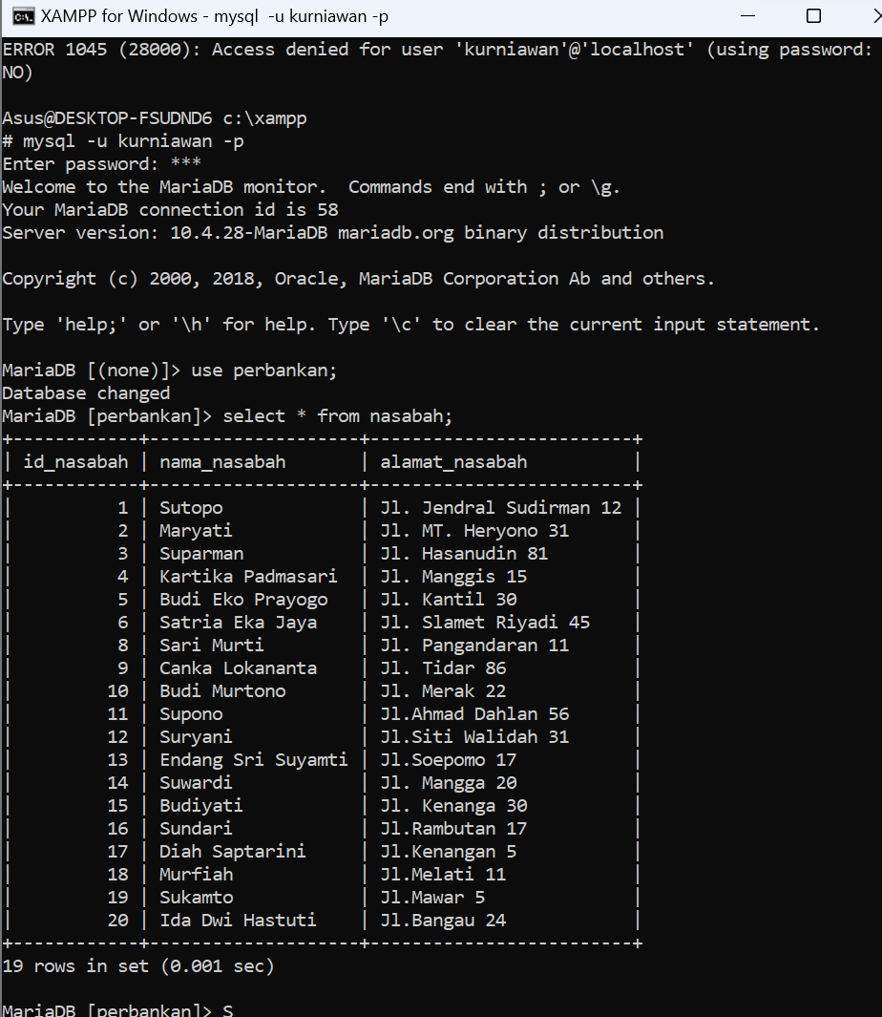

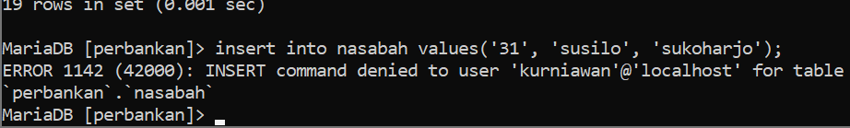

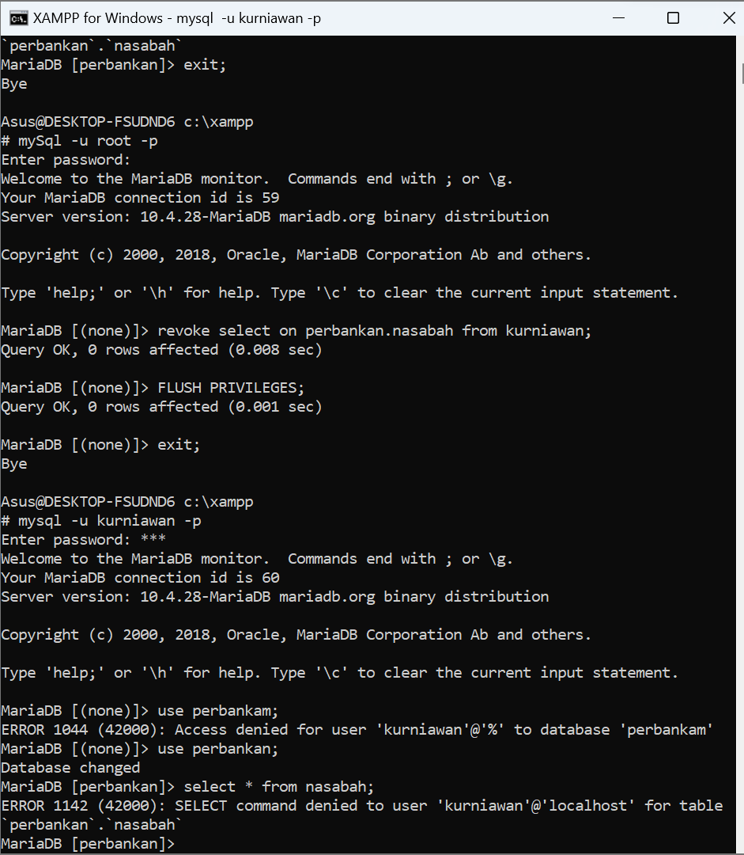

TASK

1.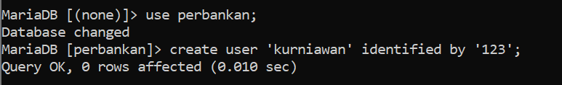

1. 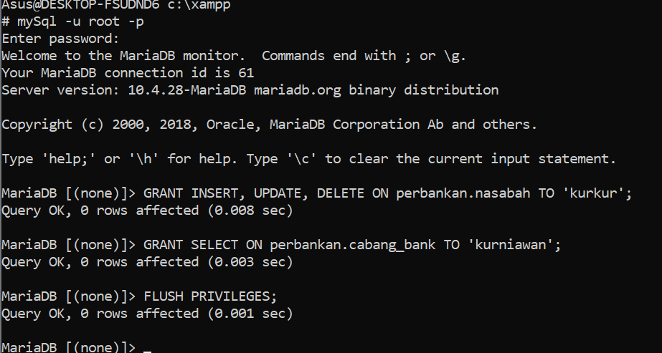
2. 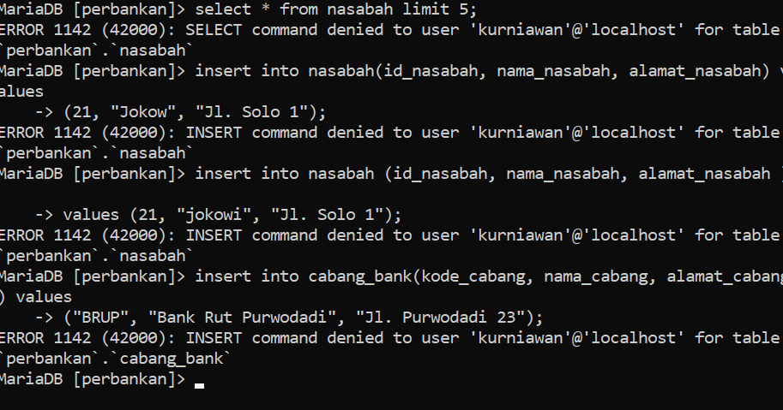
3. Based on my analysis, the point c command can still be executed even though it doesn't get a grant because it's not revoked, and vice versa. If it is not revoked, the command will still be accessible. Given what I understand is default=grant all.